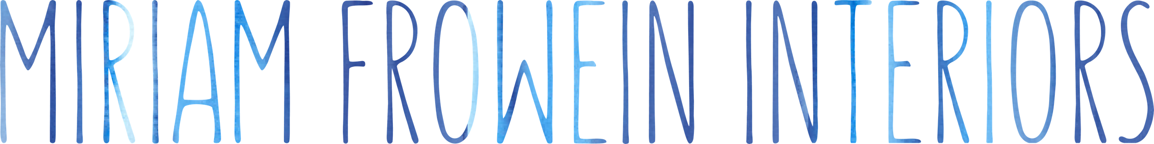

Full – time or part-time position: Monday to Friday (Friday is working from home) or Monday to Wednesday
Location: Belgravia, London
Salary: Dependent on Experience

Miriam Frowein Interiors is seeking a studio manager to join its team in Belgravia, London.
We are searching for an exceptional, highly organised individual to take on the integral role as studio manager for our boutique firm.
This is a varied position where you will be coordinating the day to day running of a busy design studio, involved in both the administration and design aspects of the business. You will oversee the design team, manage workflow, as well as having a key role in FF&E specification.
The role:
- manage the office facilities, equipment, IT and supplies
- book UK and overseas travel/accommodation for designers
- collate and file travel expenses, liaising with our office accountant
- conduct internal meetings, manage diaries and book appointments
- manage marketing opportunities and company social media effectively
- manage project workflow by maintaining existing filing systems and ensuring deadlines are met
- occasional travel may be required (taking minutes and supporting the design team in meetings)
- source and specify FF&E for projects, working closely with the design team as well as managing the procurement stage
- creating power point presentations
- liaise with shipyards, clients and suppliers in a polite and efficient manner
- you will be the main point of contact for the studio both externally and for all staff members
- ensure the office is always running smoothly and maintained to a high standard
The successful person will have the following skills:
- micromanagement, problem-solving, good judgement, ability to listen, empathy and approachability
- strong understanding of how the interior design industry works and a keen interest in interiors
- ability to work well under pressure, prioritise and meet deadlines
- to be on hand to assist team members when required
- excellent written and verbal communication in the English language
- flexible, self-motivated and a good team spirit
- strong skills in Microsoft Office including excel as well as Power Point
- Photoshop, InDesign and AutoCAD also very desirable
- ability to source furniture and fabrics for interior schemes, presenting them in person and in digital format
- able to quickly learn and retain a great depth of product knowledge
- experience of working within a design studio is highly desirable

Please email us your application with a CV as well as brief covering letter to info@froweininteriors.com.

