Sales Coordinator, Pimlico London
Are you a highly organised, focused and proactive individual looking to embark on an engaging career? Do you have a passion for fabrics and interior design? Do you have excellent administrative skills with knowledge of the interior design/ luxury trade industry? If so, this is a great opportunity to take your next step as a Sales Co-ordinator.
Who will I be working for?
de le Cuona is an award-winning designer and manufacturer of exceptional fabrics. With over 20 years of success, they source high-quality materials to create luxury products.

Location: The role will primarily be based at our Retail and Trade Showroom in Pimlico, but the role will require flexibility to float between the Pimlico and Chelsea Harbour showrooms.
Salary Range: £24,000-£28,000 per annum
Contract: normal working hours are 9:00am – 6pm and you will be required to work late when necessary. The Pimlico Showroom opens on Saturdays; therefore, some weekend work will be required.

Summary of Main Duties and Responsibilities:

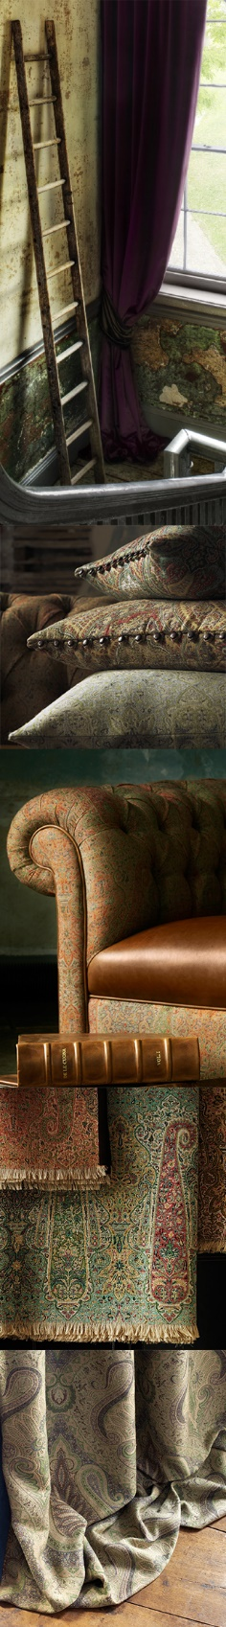
As the Sales Co-ordinator you will supporting administratively all aspects of showroom operations (for both showrooms). With the sales team (field/showrooms/bespoke service), giving support and being the main link with HQ and sales department. You will be assisting the Business Development Manager on all administrative processes and supporting the department as required.
Reporting to the Business Development Manager, with a key focus on supporting the team, sales operation, client service, stock management, profitability, and administration, your objectives will be achieved through your ability to support and assist the team of Showroom Assistants

Key Responsibilities

- Support administratively the BDM so the leadership, training and development of the showroom sales teams are done smoothly in order to exceed sales targets and grow the brand image.
- Support the showroom teams in the daily running of the showroom operations to de Le Cuona’s high standards.
- Support the sales team in developing relationships with existing clients and engage new High Net Worth (HNW) clients.
- Assist in the showrooms with Interior Design & Accessories and sourcing fabrics and accessories.
- Plan and implement showroom display and visual merchandising to the highest standards as per dLC guidelines.
- Manage and prepare the organisation of seasonal industry and private events.
- Manage stock and stock takes. Stock request, transfers, header loans and processing returns.
- Support the BDM on the running of the sales operation from an administration perspective – coordinating and liaising with different departments on sales projects and initiatives
- Support the Field Sales, Client Liaison, Bespoke and Marketing teams – be the link between them and the Sales Team
- Support the BDM on preparation of reports and analytical data

Requirements:

- Strong administrative skills, must be precise, highly organised and focused.
- Experience in the interior design/luxury trade industry preferable
- Interest in interiors, fabrics and furniture
- Knowledge in History of Style, Enthusiasm and knowledge of Mid Century furniture designers and their work
- Self-starter, results oriented with a can-do attitude.
- Ability to work independently and collaboratively with the overall sales team.
- Great multi-tasking skills
- A strong and confident communicator with polished skills
- Very high standards of personal presentation
- Advanced skills in MSOffice including excel and PowerPoint

We will provide full product training, including visits to our mills in Europe.

If you are interested in this exciting opportunity and feel you have the skills and experience to be successful in this role, then please send your CV and covering letter (including confirmation of your current salary level) to employment@delecuona.com

