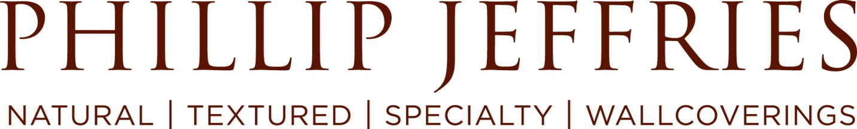

Customer Service Representative

Department: London Outside Contract Sales Rep Reports To: UK & EU Contract Manager
Post Date: 7/17/19

Phillip Jeffries is looking for a Customer Service Representative!

Our sales team is searching for a Rock Star Outside Contract Sales Representative that knows the Interior Design Industry and has fans throughout! The ideal candidate will be responsible for identifying sales opportunities within the UK contract industry.

Phillip Jeffries luxury design graces the walls of The Bellagio in Las Vegas, Saks Fifth Avenue Department Stores and numerous luxurious homes including Sir Elton John’s.

If you’re looking for a rapidly growing company that has the feel of a start-up and the foundation of an established business, Phillip Jeffries may be your next home!

This position will report directly to the UK & EU Contract Manager.

What you will be doing:

Sales Ambassador
- Grow Contract sales within the UK
- Promote sales by calling on existing and new contract specifiers and commercial interior designers, architects and purchase companies
- Place binders, sampling and point of sales material
- Prospect new customers/opportunities
- Present the brand to ensure that it is remembered
- Make outbound calls to customers following sample requests in order to close sale or recommend alternative products
- Update the CRM with pipeline sales information
- Provide weekly sales reports and monthly recaps
- Work at Exhibitions

Customer Service
- Quote pricing, stock and lead times
- Ensure promises are kept to customers
- Act as the voice of Phillip Jeffries in all contacts with customers
- Ensure satisfactory resolution to any complaint
- Provide feedback on activities as required and suggestions for improvement
- Act in an empowered way to ensure excellent service
- Ensure that product knowledge is kept up to date and of a high standard
- Achieve sales activity goals (number of appointments, binder/tip card placements, sample placements)

Must have:
- 1-3 years sales experience
- Ability to lift and carry up to 20 kilograms
- Upbeat, energetic, can-do attitude
- Leadership
- Team player
- Organization
- Strong analytical skills
- Customer-centric mentality
- Luxury brand experience
- Outstanding communication skills, both written and verbal
- Proficient in MS Office
- Well versed with ERP/CRM systems

Experience selling, tracking and reporting on a multiple project pipeline
- BA degree preferred

What’s in it for you:
- Unique culture that includes:
  - Annual Spirit Week with a focus on our core values, team building and having fun!
  - Employee-hosted Wow! Fun! Month parties (including scavenger hunts, team dinners, baseball games, etc.)
  - Annual Holiday Party and Picnic
- Competitive salary
- Paid Holidays
- Bonus Program
- Pension Scheme

For immediate consideration, please e-mail your resume, cover letter and salary requirements to jobs@phillipjeffries.com

Phillip Jeffries, the world’s leader in natural, textured and specialty wallcoverings, has been providing award winning designs to the architectural and interior design community for over 40 years. With a diverse collection of product, Phillip Jeffries has provided luxury goods that grace the walls of properties such as the Wynn Hotel in Las Vegas and the Barney’s New York stores as well as luxurious homes throughout the world.

