**PRESS RELEASE MAY 2018**



**‘EVOLUTION OF TRADITION’**

**A Celebration of Excellence, Craftsmanship & Creativity in Furniture Making**

**2** – **5 October 2018**

A new exhibition of contemporary bespoke furniture, designed by some of the UK’s most distinguished craftspeople, will launch this autumn at Design Centre, Chelsea Harbour from 2 until 5 October 2018.

The exhibition represents an exciting collaboration between The Furniture Makers’ Company, a City of London livery company and Design Centre, Chelsea Harbour, the world’s premier design destination. These two design bastions will come together for the first time to host a selling exhibition of luxury furniture designed and made purely by Bespoke Guild Mark holders.

The Bespoke Guild Mark, awarded by The Furniture Makers’ Company, is the ultimate accolade for designer-makers, recognising excellence in design, materials, craftsmanship and function for exquisite pieces of furniture.

Transforming an idea into reality takes passion, invention and vision; from seeing the potential of materials and respect for artisan processes to an openness to innovation. This curated exhibition will present a range of work of astonishing breadth, scope and artistic merit; with simple forms and strong silhouettes, many have a more modern pulse.

An impressive rollcall of established designer-makers and new talent from the vibrant British craft scene include Matthew Burt, Byron & Gómez, Jonathan Field, Marc Fish, Tim Gosling, Alun Heslop, Edward Johnson, John Makepeace OBE, Rupert McBain, Laurent Peacock, Jake Phipps, Angus Ross, Rupert Senior, Katie Walker, Waters & Acland and Waywood.

Attracting top designers, architects, international collectors and style-seekers, the ‘Evolution of Tradition’ curated exhibition will be an opportunity for visitors to gain a greater understanding of how one-of-a-kind designs are conceived and made, as well as acquire unique work. In an increasingly fast-paced world, experience the beauty and creativity of time-honoured skills from masters of their craft.

**Claire German, managing director, Design Centre, Chelsea Harbour:**

“Design Centre, Chelsea Harbour believes in the importance of investing in future talent and specialist skills. We support creative expression across the design agenda and we’re delighted to host ‘Evolution of Tradition’ showcasing the work of bespoke British furniture makers, in association with The Furniture Makers’ Company.”

**Richard Williams, Bespoke Guild Mark chairman, The Furniture Makers’ Company:**

“With its strong roster of designer-makers, all brilliant, renowned names, ‘Evolution of Tradition’ will undoubtedly be an unmissable event for buyers that demonstrates the world-class mastery of Bespoke Guild Mark holders.”

“Every piece put forward for a Bespoke Guild Mark is stringently vetted and examined to ensure every aspect of the piece is well considered and represents the absolute pinnacle of British craftsmanship. Buyers will be hard-pushed to find another exhibition of designs from a collective of so many accomplished designer-makers.”

Opening times: 9.30am – 5.30pm. Free entry.

Design Centre, Chelsea Harbour  
Lots Road  
London, SW10 0XE

[www.dcch.co.uk](http://www.dcch.co.uk)

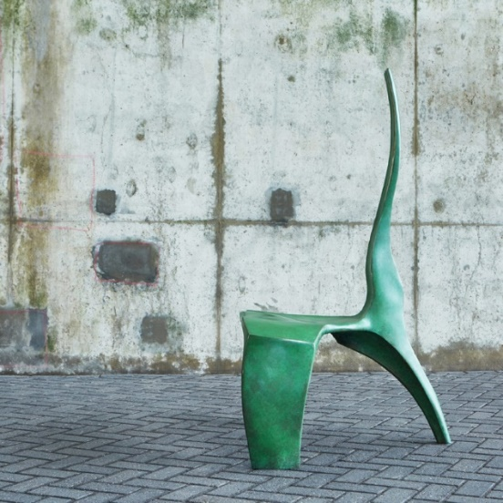

‘Dragon Kre’ chair by Alun Heslop

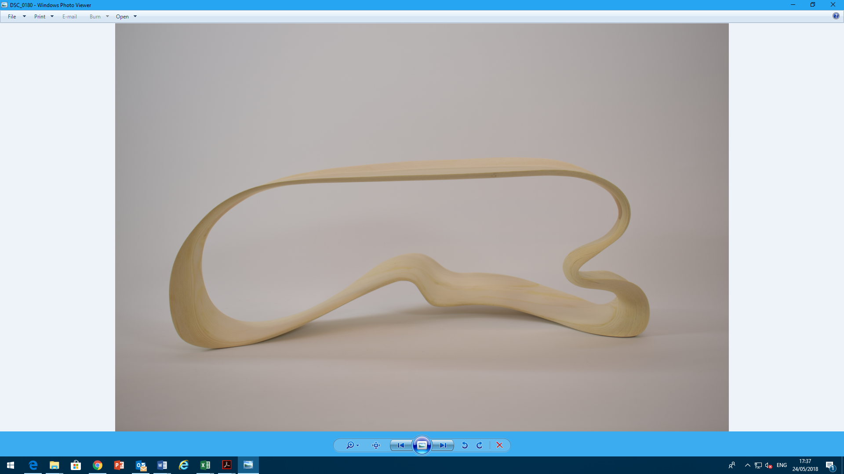

‘Ethereal’ desk by Marc Fish

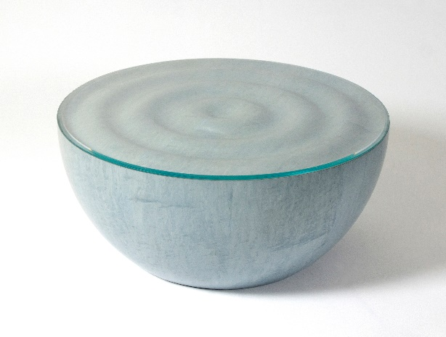

‘Splash’ coffee table by Edward Johnson

**ENDS**

Notes to editors:

**About The Furniture Makers’ Company**

The Furniture Makers’ Company is a City of London livery company and the furnishing industry’s charity. It fosters the industry by supporting those in need, nurturing skills and expertise and inspiring excellence.

For further information, contact George Cooper, [marketing@furnituremakers.org.uk](mailto:marketing@furnituremakers.org.uk) or 020 7562 8522

**About Design Centre, Chelsea Harbour**

Design Centre, Chelsea Harbour is a thriving platform, both creatively and commercially, at the heart of the global design community. Dedicated to inspire, inform and deliver creative excellence, it is the largest of its kind in Europe and home to over 600 luxury brands. Expansion has been a defining feature lately and it continues to grow and evolve, championing the best in international design talent. It is bricks, mortar and beyond.

For further information, contact Becky Metcalfe, beckymetcalfe@dcch.co.uk or 020 7225 9121