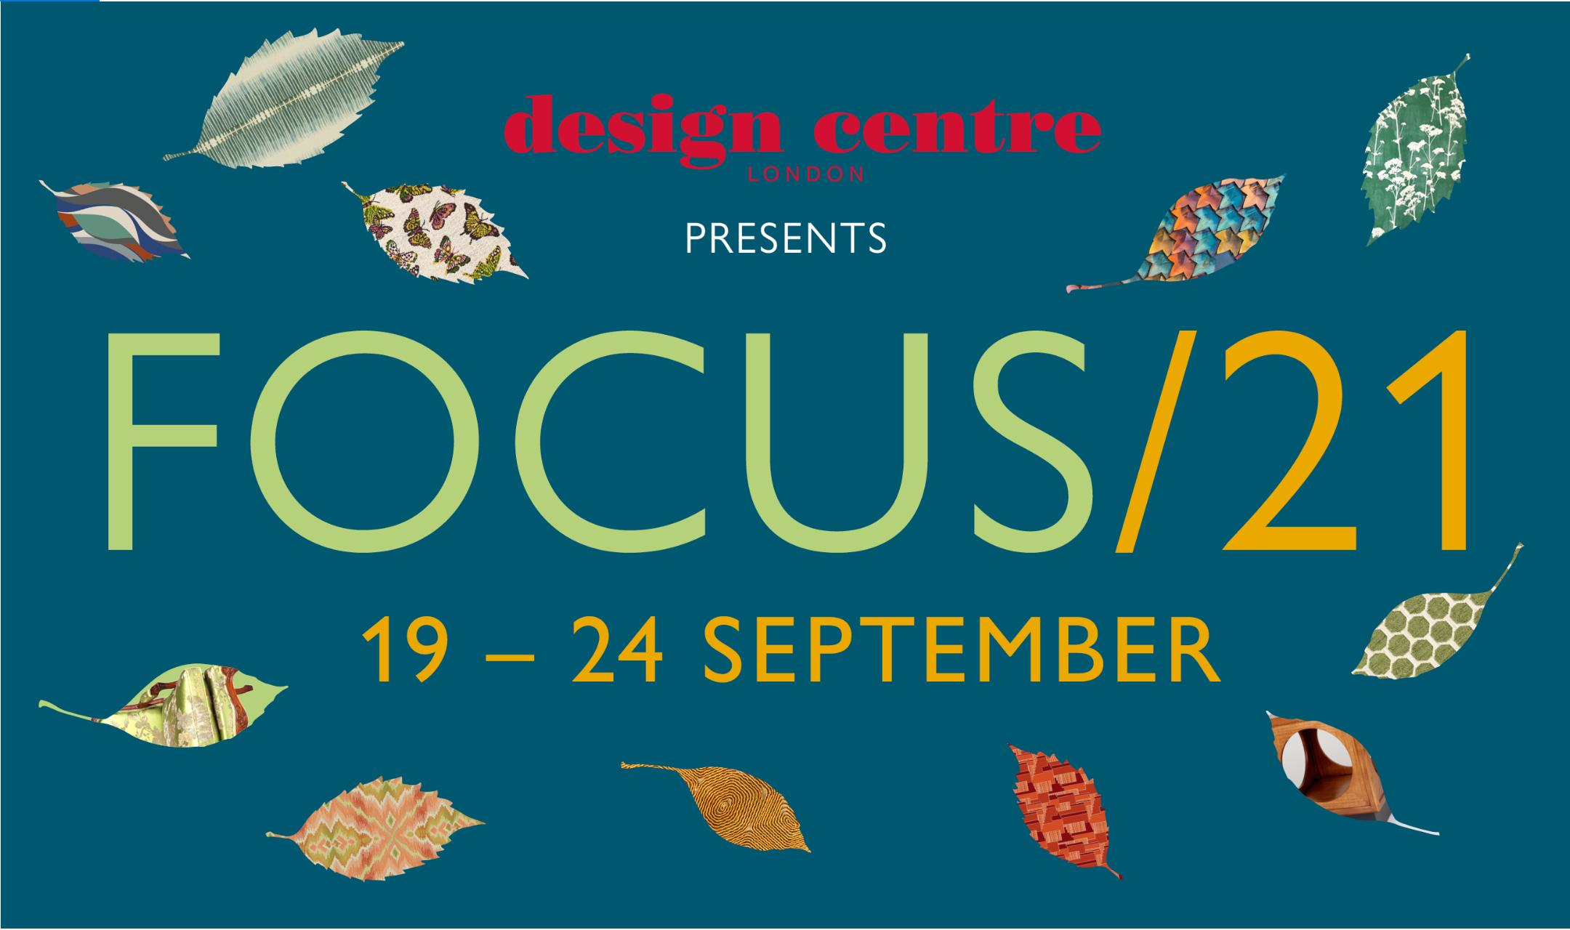
The winds of change blow into Design Centre, Chelsea Harbour for autumn’s unmissable design event
From 19 – 24 September, it will be an exciting time to be at Design Centre, Chelsea Harbour. With sights firmly set on a positive future, Focus/21 represents an exhilarating new chapter. Expect a feel-good mood as the world’s premier design destination celebrates outstanding creativity, freedom and change.
Everywhere you turn at this physical event, there will be the promise of design discovery. The latest looks at Focus/21 are cosmopolitan in outlook, underscoring the importance of individual style and quality craftsmanship. Each is distinctive; what unites them is creative confidence. New-season collections from 120 showrooms speak of stylish palettes and abstract compositions that represent power and poise. A joyful 1970s redux is infused with vitality and hope, while imaginative dreamscapes bring a sense of wonder.
Showroom teams are renowned for their specialist knowledge, so Focus/21 will be the place to talk to them about projects and see the breadth and scope of their autumn/winter 21 ranges up close. Adding another layer, pop-up House Guests will offer more ways for visitors to encounter world-class talent.
Reflecting a commitment to connect, converse, create, a curated programme will bring more verve and energy. Workshops, talks, artisan demonstrations and discovery tours will dig deeper inside the stories behind the designs and provide opportunities to meet in person the people who shaped them. All underline the astonishing capacity of the human imagination. This wealth of experience is extraordinary and, what’s more it is a free resource for every visitor.
On the main stage, industry insiders will share their experiences at the acclaimed Conversations in Design series, while installations and specially commissioned places to eat and drink will bring plenty of visual inspiration.
London is recognised as one of the world’s design capitals; Design Centre, Chelsea Harbour with its unique sense of community is leading the way. A vital industry hub with an international standing, it is recognised as an authoritative voice of interior decoration.

EVENT INFORMATION
www.dcch.co.uk
020 7225 9166

REGISTRATION
Visit www.dcch.co.uk

SOCIAL MEDIA
#Focus21AtDCCH, @designcentrech

Focus/21 remains a design calendar highlight. It will adhere to UK government guidelines at the time, and plans may be subject to change. The welfare of the Design Centre’s community of showrooms, colleagues, partners and visitors remains a number one priority.

Press information: Rebecca Gleeson, rebeccagleeson@dcch.co.uk, +44 74 36145285

