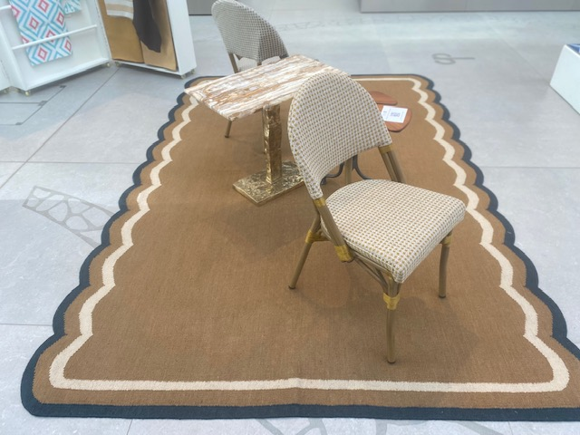

‘Scallop’ rug, Salvesen Graham at Jennifer Manners Design

Chair upholstered in ‘Bovary’ outdoor fabric, 05, Lizzo

Chair upholstered in ‘Bovary’ outdoor fabric, 04, Lizzo

‘Lapis’ side table, Link Outdoor at Colony

‘Onyx’ table, Eccotrading Design London

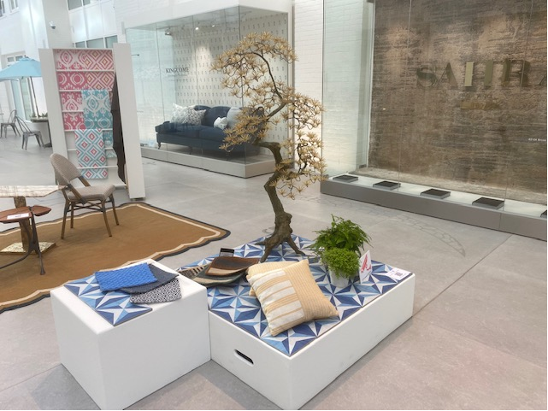

‘Large Bonsai tree, Eccotrading Design London

‘Solar’ tiles, star blue, Artisans of Devizes

‘Rua Fiesta’ outdoor fabric (213590), natural/sunflower and ‘Rua Sombrero’ outdoor fabric (213328), natural/sunflower, on cushion, C & C Milano

‘Rua Fiesta’ outdoor fabric on cushion (213590), natural/sunflower, C & C Milano

‘Mini Glass Drum’ portable lamp, Collier Webb

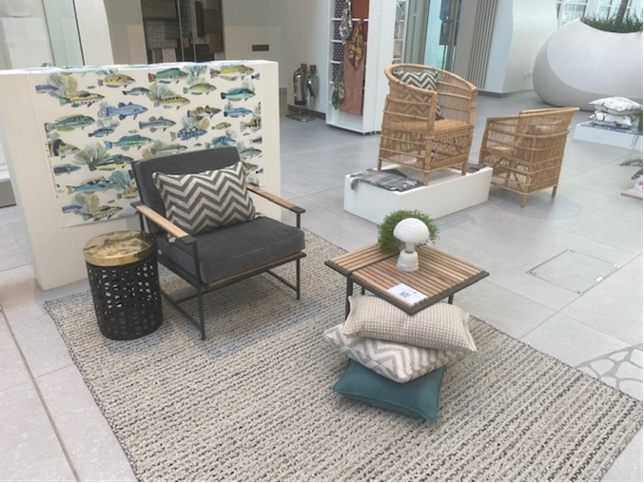

LEFT:

‘Fidji’ outdoor fabric (M4062-01), aqua, Manuel Canovas at Colefax and Fowler

‘Daybreak’ lounge chair, Link Outdoor at Colony

‘Daybreak’ side table, Link Outdoor at Colony

Braided Jute-Effect rug, Jennifer Manners Design

‘Mini Cep’ lamp, alabaster, Collier Webb

‘Mosaic’ table, Eccotrading Design London

RIGHT:

‘Marelle’, ‘Bovary’ and ‘Camelia’ assorted cushions, Lizzo

Garden armchairs, Eccotrading Design London

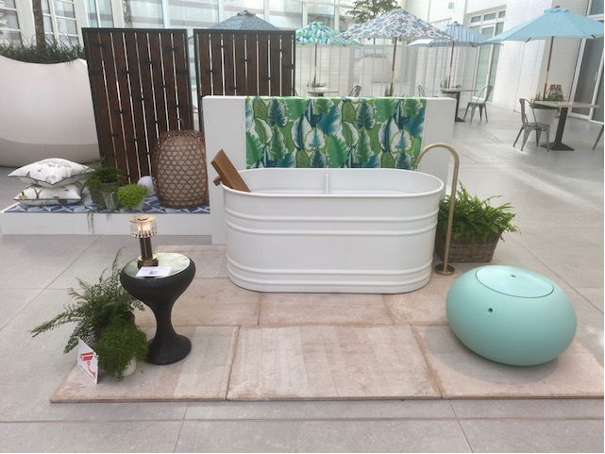

‘Buscot’ limestone tiles, Artisans of Devizes

‘Malfa’ outdoor fabric (04908/01), emeraude, Manuel Canovas at Colefax and Fowler

‘Miura’ indoor/outdoor leather (177286), English green, C & C Milano

‘Vieques’ outdoor bath, white, Agape at West One Bathrooms

‘Oscar’ floor mounted bath filler, brushed brass, ABI Interiors

‘In-Wall’ minimal mixer, ABI Interiors

‘Sugarplum’ stool, Formitura at Toplfoor by Esti

‘Lava’ table, Eccotrading Design London

'Woven Orb' lantern, Alexander Lamont at Alexander Lamont + Miles

Wood panels, Eccotrading Design London

‘Noah Multi’ outdoor cushion (ACC5085), Andrew Martin

‘Friendly Folk’ outdoor cushion (ACC5083), dusk, Andrew Martin

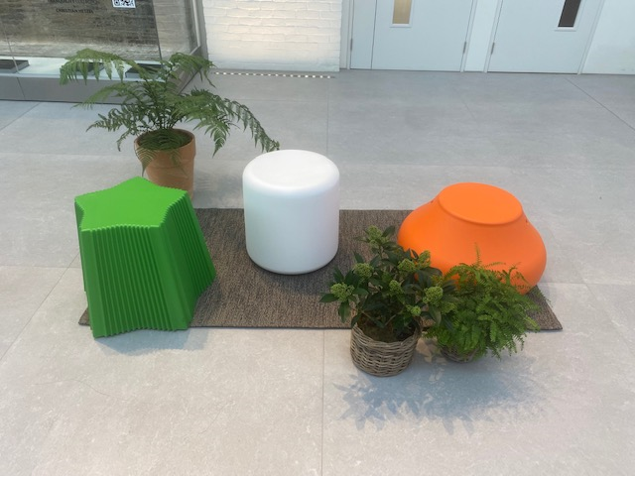

‘Peardrop’ stool, Formitura at Topfloor by Esti

‘Marshmallow’ stool, Formitura at Topfloor by Esti

‘Gingerbread’ stool, Formitura at Topfloor by Esti

‘Berry’ runners, Topfloor by Esti