Lincrusta – Showroom Manager

Lincrusta are looking to recruit a Showroom Manager for their Chelsea Harbour Showroom.

For this exciting role we are looking for an experienced and motivated person who will make a crucial contribution to the successful development of the brand in the Architect & Design sector. Main responsibilities will involve managing our new showroom, assisting clients with design and decorative decisions and making sure that sales targets are exceeded.

Manufactured in Britain since 1877, Lincrusta is the ultimate wallcovering which has never needed improving. Distinctive and defining, there is no other wallcovering as luxurious or durable as Lincrusta.

Our head office and factory are based in Lancashire, UK

Job Description

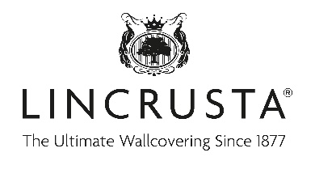

Position: Showroom Manager, Chelsea Harbour
Type: Full time, permanent
Salary: Negotiable dependent on experience

Applicant:

- Experienced Sales Manager in the interior design sector, preferably in a showroom environment.
- Proven track record of sales within the luxury interior design sector.
- A confident decision-maker, you’ll have the ability to influence decisions and take full responsibility for driving performance, sales and service.
- With good attention to detail and good IT skills, you’ll also be a team player with strong interpersonal skills, able to manage and motivate staff and communicate at all levels with colleagues and clients.

Main responsibilities:

- Manage all aspects of the day to day running of the showroom.
- Ensure the showroom is well-presented at all times and assist clients with the selection of designs and decorative schemes.
- Build and grow client account base through brand exposure opportunities, marketing events and other initiatives as well as regular contact and communication, making sure targets are exceeded.
- Manage client orders through head office to ensure goods are delivered accurately and in a timely manner.
- Manage, motivate and develop other showroom staff.
- Keep the sample library up to date.
- Report regularly to the Management team on performance against specified KPI’s.

To apply, please send your CV and covering letter stating salary expectations to Martin O’Kane at martin.okane@lincrusta.com

