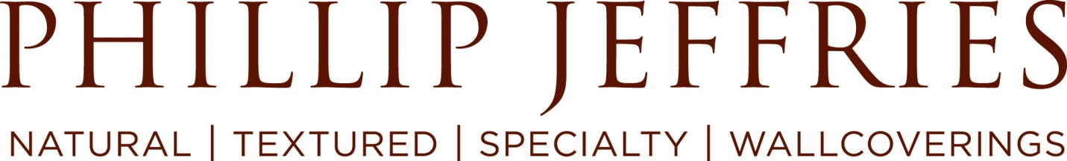

Phillip Jeffries is looking for a Customer Service Representative!

If you're looking for a rapidly growing company that has the feel of a start-up and the foundation of an established business, Phillip Jeffries may be your next home!

Who is Phillip Jeffries?

We are an award winning American wallcovering design company recognized by Interior Design Magazine and their 70,000+ interior designer subscribers as BEST OF YEAR WALLCOVERING WINNER – BACK TO BACK YEARS!

Phillip Jeffries is luxury design gracing the walls of The Bellagio in Las Vegas, Saks Fifth Avenue Department Stores and numerous luxurious homes including Sir Elton John’s.

We are searching for the right team player to join as a customer service representative in our UK, Chelsea Harbour based Showroom. Individuals must fit within our unique corporate culture and be dedicated to the growth of our business.

What you will be doing:
- Own all Data Entry Functions
  - Enter purchase orders
  - Enter sales orders
- Own all Order Shipment facilitation
  - Release orders
  - Create shipping documents (Customs & SLI)
  - Create packing slips
  - Track all shipments & provide details to Customer
- Offer World Class Customer Support
  - Before, during & after the point of sale (as needed)
  - Ensure swift & win/win resolutions to any claims
- Assist in Customer Follow up
  - Follow up on memo orders
  - Follow up on all open reserves

Must have:

Upbeat, energetic, can-do attitude

2 years’ experience in customer service, sales support and/or retail

Outstanding communication skills, both verbal and written, and exceptional phone manner

Workable knowledge of French is required

Excellent time management and follow up skills

Able to multitask and prioritize

Strong analytical skills, Able to work in a fast-paced, team-oriented environment - displaying initiative and common sense

Proactive approach to problem solving
- Excellent organisation skills and attention to detail in tasks
- Strong computer skills including data management, Word and Excel
- Retail backgrounds welcome
- A keen interest and appreciation for luxury products and interior design

Why Phillip Jeffries?
As a purpose-driven organization, we truly believe that where you work matters. We are committed to creating an organization with a higher purpose, a place where our talented team can truly flourish. Phillip Jeffries believes in creating an environment with opportunities to grow personally and financially, offering volunteer opportunities that support our community and environment as well as extending a rich benefits package to care for our most valuable assets, our team.

Perks:
- Unique culture that includes an annual Spirit Week with a focus on our core values, team building and having fun!
- Frequent team building activities
- Annual holiday party and picnic
- Paid time off for community service with the ability to take (3) paid days off per year to volunteer during a work day and (3) days per year on a weekend earning you an additional (3) days of comp time
- Business casual dress code

Benefits:
- Competitive salary
- 23 paid days off
- Paid holidays
- Bonus program

For immediate consideration, please e-mail your resume, cover letter and salary requirements to https://phillipj.bamboohr.com/jobs/view.php?id=186 or Jobs@phillipjeffries.com.

Phillip Jeffries, the world’s leader in natural, textured and specialty wallcoverings, has been providing award winning designs to the architectural and interior design community for over 40 years. With a diverse collection of product, Phillip Jeffries has provided luxury goods that grace the walls of properties such as the Wynn Hotel in Las Vegas and the Barney’s New York stores as well as luxurious homes throughout the world.

To learn more about Phillip Jeffries, please visit us at www.phillipjeffries.com.

