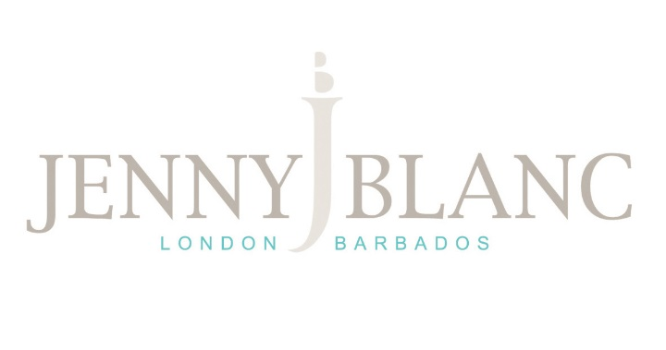
Senior Designer

A unique opportunity:
We have a wonderful opportunity for a Senior Interior Designer to join our award winning company during an exciting period of change and growth. You will be based primarily at our showroom and design studio in Teddington, West London but may also be required to travel to and work from the Barbados showroom as and when required.
Qualities and skills we’re looking for:
The most important qualities for this role are natural creative flair and a love of fabrics combined with an eclectic style. We are particularly looking for someone who is able to confidently combine commissioned furniture with antiques alongside cutting edge furniture, home accessories, fabrics and wallcoverings from our large library of suppliers. In addition to being imaginative and resourceful, a background working on prestigious residential projects in the UK is essential.
You must possess a CAD qualification and be able to create and edit technical drawings. A strong all-round IT skill set is essential with particular emphasis on Excel as this forms the basis for the costing of all projects. Attention to fine detail and a good head for figures are also essential as you will be responsible for the accuracy of all summaries and invoices produced by the design team.
You must have your own car and a full, clean driving licence and be well presented with fluent English.
Day to day responsibilities:
As well as leading on all design work in the UK (and assisting the Caribbean where required) under Jenny Blanc’s direction, you will also be responsible for the smooth running of our busy design department on a day-to-day basis and will be the main point of contact for clients during all stages of their project. You will skilfully manage all design projects from beginning to end, building good working relationships with our clients, contractors and suppliers.
You will be responsible for recruiting and mentoring more junior members of the design team, nurturing their development as well as overseeing their work to ensure that it is carried out to the highest standard.
This role requires a flexible approach and you will sometimes be required to assist in the showroom, for example, helping customers choose fabrics and wallpaper or by discussing our design services in detail.
The senior designer will work directly under Jenny Blanc and you will receive mentoring and training in the company’s signature design style. You will be required to support the design work of the other two designer directors – Emma Blanc who is based in Barbados and runs the Caribbean side of the company and Chrissie Marshall who is the UK Showroom Director delivering our very successful ‘Just Rooms’ design service.
Future potential:
This is a very interesting and exciting role with a great amount of scope for progression as the company expands. As well as the two showrooms in West London and the Caribbean, we have our own furniture collection designed in house which is constantly evolving. This role will allow the opportunity to be involved with the design of new pieces of furniture both for the Jenny Blanc Furniture Collection and for bespoke commissions for our design clients. With a new website and e-commerce store in the pipeline, the new Senior Designer will join us at an exciting time as the companies profile increases internationally.
Days/Hours: Monday – Friday, 9 am – 6 pm
To apply, please send your CV and covering letter to jennyblanc@jennyblanc.com
Starting salary: Salary negotiable depending on experience

