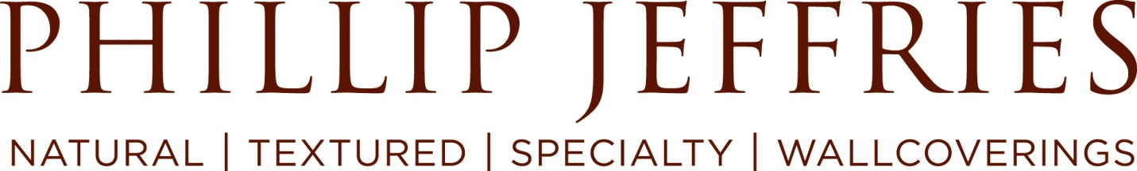

Customer Service Representative

Department: UK CHA Reports To: UK Regional Manager
Post Date: March 2019 Strata: II

Phillip Jeffries is looking for a Customer Service Supervisor!

Our Customer Service team aims to “WOW” our customers! We are searching for a customer-centric team player that is committed to providing the world’s best service and leadership for our UK team.

This position will be located in our brand new offices in London. Candidate must be willing to “get their hands dirty” in order to learn all facets of the operation.

If you’re looking for a rapidly growing company that has the feel of a start-up and the foundation of an established business, Phillip Jeffries may be your next home!

This position will report directly to the UK Regional Manager

What you will be doing:
Customer Service
- Own all Data Entry Functions
  - Enter purchase orders
  - Enter sales orders
- Own all Order Shipment facilitation
  - Release orders
  - Create shipping documents (Customs & SLI)
  - Create packing slips
  - Track all shipments & provide details to Customer
- Train and Support the CHA and Sampling Team
- Offer World Class Customer Support
  - Before, during & after the point of sale (as needed)
  - Ensure swift & win/win resolutions to any claims
- Assist in Customer Follow up
  - Follow up on memo orders
- Follow up on all open reserves
Sales:
- Answer inbound sales calls and emails and input sample requests and order details into the computerized ordering system
- Proactively recognize cross selling opportunities, using product knowledge to offer similar patterns and designs to customers in order to increase revenue
- Make outbound calls to customers following sample requests in order to close sale or recommend alternative products
- Process payments

Must have:

Upbeat, energetic, can-do attitude

Approachable

Being able to work under pressure

Being able to monitor team workload

Outstanding communication skills, both verbal and written

Excellent time management and follow up skills

Able to multitask and prioritize

Able to work in a fast-paced, team-oriented environment

Proactive approach to problem solving

Excellent organizational skills

Strong attention to detail

Strong computer skills including data management, Word and Excel

2 years’ experience in customer service, sales support and/or retail

Keen interest and appreciation for luxury products and interior design

What’s in it for you:

Unique culture that includes:

Annual Spirit Week with a focus on our core values, team building and having fun!

Employee-hosted Wow! Fun! Monthly parties (including scavenger hunts, team dinners, baseball games, etc.)

Annual Holiday Party and Picnic

Competitive Salary

Paid Holidays

Bonus Program

Phillip Jeffries, the world’s leader in natural, textured and specialty wallcoverings, has been providing award winning designs to the architectural and interior design community for over 40 years. With a diverse collection of product, Phillip Jeffries has provided luxury goods that grace the walls of properties such as the Wynn Hotel in Las Vegas and the Barney’s New York stores as well as luxurious homes throughout the world.

To learn more about Phillip Jeffries, please visit us at www.phillipjeffries.com.

