

Global Event Explores the Superyachts of Tomorrow at
Design Centre, Chelsea Harbour
28 – 30 June 2016

SuperyachtDESIGN Week (28 – 30 June 2016) returns to Design Centre, Chelsea Harbour with a vibrant, new programme that brings together forward thinkers from around the globe. In today’s luxury market, superyachts need to meet and exceed the client’s brief; this event promises to explore how to achieve the extraordinary.

Visitors to SuperyachtDESIGN Week can interact with titans from the industry, be inspired by the potential of materials as well as learn about complex techniques and innovative technology up close. The comprehensive programme is simply unmissable and is packed with workshops, talks, artisan showcases and a host of networking opportunities with design connoisseurs and pioneering experts.

Now in its fourth year, it attracts leading speakers from the superyacht world and beyond, giving a unique perspective on the future of large yacht design. Keynote speakers include Guillame Rolland, principal architect at Christian Liagre and Ian Briggs of BAC Mono who will discuss the ground-breaking technology changing the face of performance cars and their relationship with the marine world.

Workshops include sessions on the making of Moonstone with the Oceanco and van Geest Design teams, ways to work closely with owners to create bespoke experiences with Timur Bozca and Casper Kleiman of Van Berge Henegouwen, insights from crew on how to design better for life on board as well as discussions on the buying process, social media and contracts.

Specially tailored for this specialist market, it is all about engaging with people who matter. A new initiative is ‘Supper Club’, an evening of intimate get-togethers for creative minds to exchange ideas on what is new and relevant for tomorrow’s superyachts. ‘Discovering Design with’ gives visitors greater interaction with the Design Centre showrooms to discover the latest style directions, seek out specialist products and take advantage of the expert knowledge on site.

SuperyachtDESIGN Week has firmly established itself as an authoritative compass for this ever-evolving sector of the design industry. Visitors can source every last detail of a yacht scheme from global names at Design Centre, Chelsea Harbour, Europe’s premier design destination. With an influx of new arrivals this year, expect to take in even more international talent.

Event details:
Visit www.SuperyachtDESIGNWeek.com or contact The Superyacht Group team on +44 (0) 207 924 4004.

Event Partners:
Gold • Blohm + Voss
Silver • Clyde & Co
Bronze • Jotun • LuxperienceLab • dkt Artworks • Rina

NOTES TO EDITORS
SuperyachtDESIGN Week event is hosted by:
Superyacht Design: The industry-leading media platform that aims to educate, inspire and challenge the latest topics relating to large yacht design, it delivers a unique opportunity to engage with designers, naval architects, shipyard managers, owners and captains. SuperyachtDesign magazine is published quarterly and distributed globally, direct to industry professionals involved with the design and construction of yachts over 30m. Providing unrivalled journalism, it is enhanced by a product special and SuperyachtDESIGNERS, containing the Designer Global Order Book with insight into the teams behind innovative ideas, projects and products. It is complemented by SuperyachtDesign.com.

Design Centre, Chelsea Harbour: With 116 showrooms and over 600 international brands - nowhere else will you find such a high concentration of design’s biggest names shaping luxury yacht interiors today. What is on offer is couture for the home, whether on land or at sea. Showcasing the highest expressions of creativity, it is the remarkable level of sophistication that truly defines. Excelling in a range of specialist areas including fabrics and wallcoverings, furniture, lighting, carpets, hardware, alongside handcrafted and bespoke products, it is a recognised hub for superyacht design. Recent initiatives include the development of Design Centre East and a significant influx of 12 international showrooms.

Organised by: Superyacht Events




Press information:
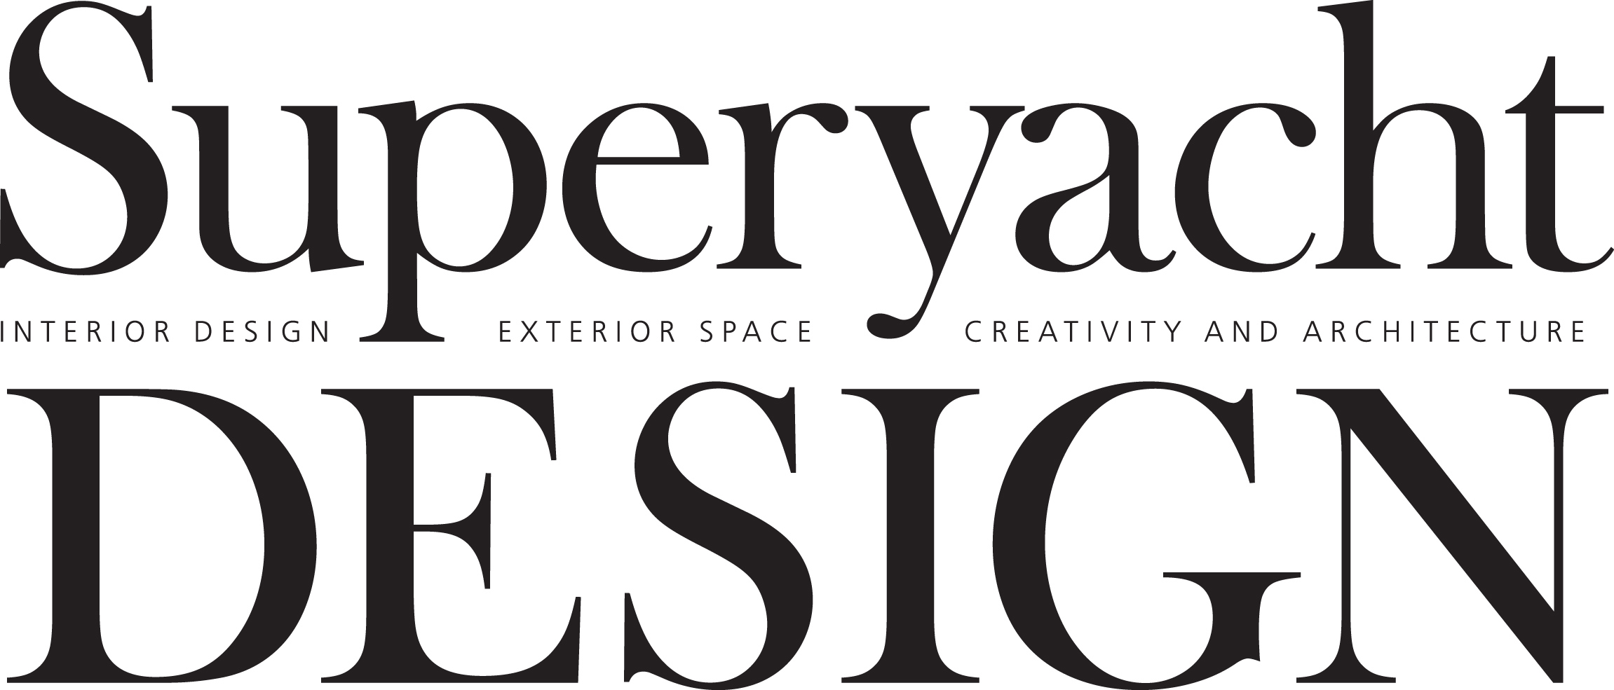


For further information, please contact Rachel Rowney, programme manager at Superyacht Events on rachel@thesuperyachtgroup .com or call +44 (0) 207 924 4004.

