Press Information

DESIGN CENTRE, CHELSEA HARBOUR
THE WORLD’S PREMIER DESIGN DESTINATION

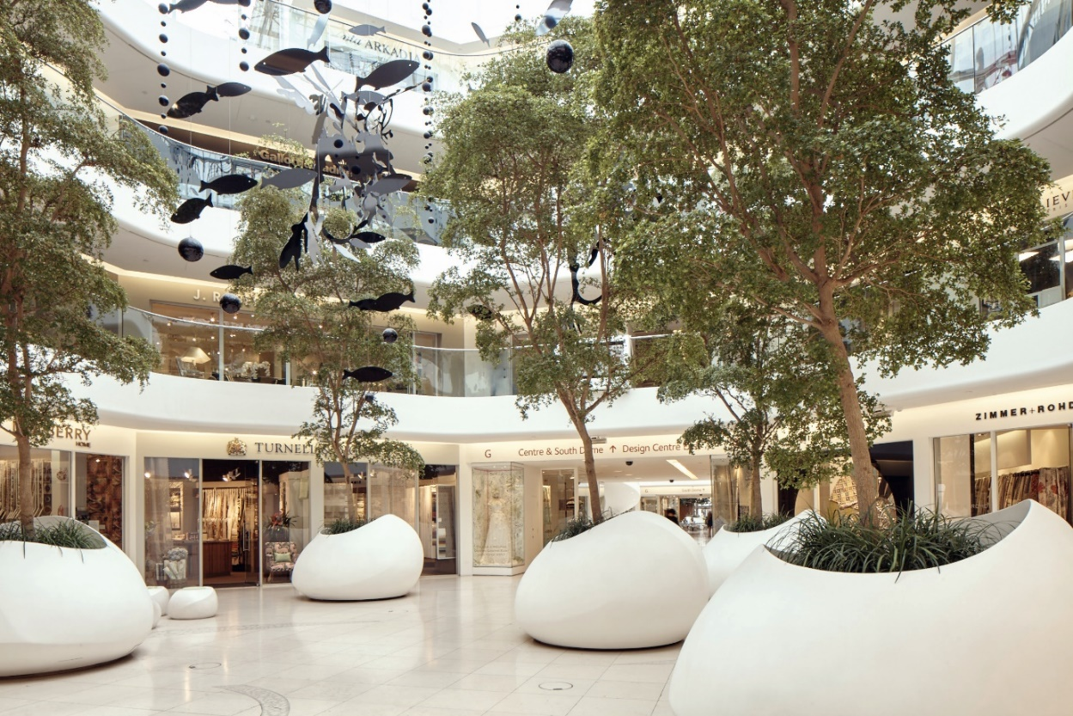

For the best in design and decoration, look no further than Design Centre, Chelsea Harbour.

A commitment to design excellence has put it firmly on the map. More than a design resource, it is a thriving platform, both creatively and commercially, for an exceptionally dynamic industry. It is the largest of its kind in Europe and well-established as a premier design destination. Nowhere else will you find such a high concentration of design’s biggest names shaping luxury interiors today – all at one address.

Design Centre, Chelsea Harbour has long been a catalyst of creative connections, but now an exciting new chapter is unfolding. With strategic expansion on the horizon, some highly influential names moving in and a landmark building project on the way, the sense of community (already one of its greatest strengths) is set to get stronger.

Design Centre, Chelsea Harbour is the first port of call for professional interior designers, architects, specifiers and style-seekers looking for specialist expertise. Dedicated to inspire, inform and deliver the best in design, it is the perfect place to discover world-class talent, connect with influencers, established makers, emerging innovators and luxury brands, as well as get the inside track at high profile events such as Focus and London Design Week.

In fact, it is a measure of Design Centre, Chelsea Harbour’s influence that people fly in from all over the world to see what is on the style radar. It is an astonishing treasure trove of fabrics, furniture, lighting, wallcoverings, accessories, kitchens, bathrooms, outdoor living, trimmings, leather, hardware, tiles and carpets of the highest calibre. On every floor, there are designs of originality and invention conjured up by great British brands as well as star names from further afield. All are celebrated for their quality, creativity, skilled craftsmanship and technical ability. Details like impeccable materials and

finishes are at their best close up, and in an increasingly fast-paced world, visitors can experience exceptional products in person as well as seek out expertise in the showrooms. Bespoke products are another forte – with countless companies creating tailor-made pieces. In short, what is on offer is ‘couture for the home’.

As beautiful as the designs within it, it is no coincidence that every aspect of Design Centre, Chelsea Harbour has been conceived to create the ultimate environment. It is at the epicentre of a larger 697,000 sq. ft. development. Fronting the famous river Thames, this includes a marina for 80 luxury yachts, as well as a 5-star hotel, private residences and commercial offices. The transformation of the Design Centre itself began in 2005 with the introduction of sleek glass balustrades and contemporary showroom frontage, delivering cohesion throughout. Black olive trees were brought in as the finishing touches to a £6m total refurbishment scheme, bringing natural life into the iconic domes. More recently, further expansion of Design Centre East has linked it more closely with the domes.

120 international showrooms cater not only for those who have a passion for creating their own projects, but for professional designers who are working on the interiors of world-famous hotels, bars, restaurants and boutiques. What you see in the showrooms is just the starting point. Products that have been sourced at Design Centre, Chelsea Harbour include lighting for Claridge’s; leathers for the Aqua Shard in London and also for the Hilton hotel in Dubai, rugs for the Four Seasons presidential suites; handmade wallpapers for the Shangri-La in Paris and for The Jefferson in Washington DC; silks for Cliveden hotel and hand-blocked fabric for Ham Yard Hotel; custom carpets for ‘Ace’, a 87m superyacht; and a bespoke champagne bar for the Mandarin Oriental in Knightsbridge. International visitors include fashion designers, stars of stage and screen, royalty, financiers and high-net worth individuals.

Design Centre, Chelsea Harbour plays a central role in Britain’s cultural landscape. A continuous roster of events that engage and inspire is an essential ingredient of the experience. Every year Focus and London Design Week are a must on the international design calendar, while events such as SuperyachtDesign Forum or Spotlight on Contract Interiors are more tightly focused to closely mirror specialist needs. Sharing ideas and generating a deeper understanding of design are at the heart of it all, from the Access All Areas sessions in the showrooms to workshops and bi-monthly design discovery tours. With a burgeoning interest in the design narrative, the popularity of these immersive sessions has accounted for a huge growth – at London Design Week 2018, for example, there were over 127 events in six days. This fusion of design encounters offers a dynamic collective unseen anywhere else.

The exchange of views is paramount to a dynamic design industry. The acclaimed ‘Conversations in Design’ programme has gained much momentum in recent years with renowned names from the international stage eager to share their design knowledge. An impressive line-up of design superstars has included Patricia Urquiola, Rosita Missoni, Kit Kemp, David Mlinaric, Ilse Crawford, Tom Dixon, Patrizia Moroso, David Rockwell, Barbara Barry, Martin Brudnizki, India Mahdavi, Lee Broom and Michael S Smith, to name but a few. From seminars on the future of hospitality design and the blurring of art and interiors to new markets in Brazil and Asia and the impact of 3D printing, Design Centre, Chelsea Harbour is committed to hosting topical and engaging discussions.

Design Centre, Chelsea Harbour supports a broad spectrum of creative disciplines across the design agenda. A natural home for creative expression, exhibitions have included ‘Marilyn Monroe: Legacy of a Legend’ which showed never-seen-before personal treasures and original costumes from films like ‘Some Like It Hot’ and ‘Art & Interiors’, a curated exhibition featuring photography, paintings and sculptures that inspired leading designers. In 2017, it hosted ‘East Meets West’ celebrating the influence of Asian design.

New initiatives are introduced to offer specialist interest and inspiration. Coinciding with nationwide campaigns, Design Centre, Chelsea Harbour has supported Wool Week since the start. It was developed by a coalition of industry groups convened by HRH The Prince of Wales to educate consumers about the premium quality of wool. Individual tours are arranged regularly for developers in residential, retail and premier property. Bringing the design community together, the annual Twinkle of Christmas is a much-anticipated evening when the domes are illuminated with thousands of festive lights.

Keen to foster creativity and push artistic boundaries, new pop-ups and installations are commissioned on a regular basis to work in harmony with Design Centre, Chelsea Harbour’s famous architecture. They have included a floral sky of 6,500 blooms by floral artist Rebecca Louise Law. (As well as working in public spaces and museums, she has collaborated with leading fashion brands such as Hermès and Salvatore Ferragamo). Fashion illustrator Megan Hess, who has a huge international following and is known for her work with luxury brands such as Chanel, Dior and Rolex, was asked to depict the glamorous world of Design Centre, Chelsea Harbour in her signature style.

Third party luxury brand partnerships build on core values of quality and choice. From global launches, photographic exhibitions, creative showcases to pop-up tasting bars and seated dinners, these collaborations encourage exchange of ideas and social interaction. A measure of how highly Design Centre, Chelsea Harbour is regarded is the number of luxury brands that want to partner with it. For example, Land Rover chose it for the launch of the Range Rover Evoque to their global dealer network.

There are few things more hotly anticipated in the design world than the latest design directions and the launch of new collections. Design Centre, Chelsea Harbour not only has its pulse firmly on global trends, but is setting them. With access to the latest new directions, the style-savvy can get the inside track on the pieces and people making waves via The Guide, dedicated newsletters and trend reports, as well as online via the website, Instagram, Twitter and a design blog that reaches out to an expanding digital audience. With breaking news as well as interviews with the people who make great design happen, it offers unprecedented authoritative access.

Design Club, a private members’ club for like-minded people in the design and creative industries, is hard to beat. The sleek interior by award-winning designer Rabih Hage is a stylish base to work, meet or entertain.

What began over twenty years ago as a spectacular building near the River Thames, has grown into much, much more. Today, visitors to Design Centre, Chelsea Harbour are encouraged to shop and spend time in the domes. As well as visiting the showrooms, they can browse through specialist titles in the bookshop or stop to refuel at the Design or Dome Cafés. From greeting you at the door to the friendly concierge desk, the on-site team is on hand to help visitors navigate what is on offer with ease. High definition screens and smart interactive display cases keep everyone informed about the latest news and activities.

The spotlight is now on Design East which now boasts over 40 showrooms, and work has already started on the Design Avenue, a permanent atrium linking it with the domes. Critical mass is hugely powerful and, by extending the design offering, a world of new possibilities is opening up with even more opportunities for visitors to connect with design connoisseurs, attend events and engage with experts in their fields.

Design Centre, Chelsea Harbour is bricks, mortar and beyond.

Design Centre, Chelsea Harbour is accessible by train, bus, tube or river taxi and there is secure parking for cars.

Design Centre, Chelsea Harbour
London SW10 0XE
Opening times: Monday to Friday, 9.30am - 5.30pm

020 7225 9166
www.dcch.co.uk
enquiries@dcch.co.uk
@designcentrech

For further press information, please contact: Becky Metcalfe
Tel: 020 7225 9121 or email press@dcch.co.uk

